**Hide Implementation With Interface**

|  |  |  |
| --- | --- | --- |
| *client code directly accesses features of an implementation class despite the presence of an interface* |  | *restrict the client code its use of features to those provided by the available interface* |

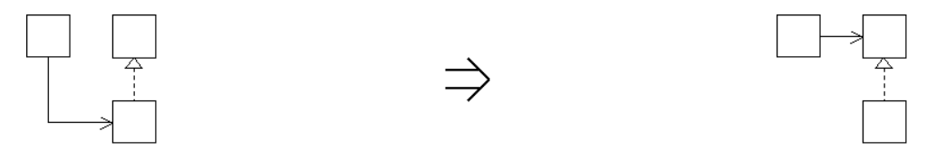

**Context:**  
[Hide Implementation With Interface](https://web.archive.org/web/20090914101013/http:/www.refactoring.be/thumbnails/rtn-hiwi.html) is a natural step after [Separate Interface From Implementation](https://web.archive.org/web/20090914101013/http:/www.refactoring.be/thumbnails/rtn-sifi.html) to upgrade any clients that still access implementation classes directly.